Communicable diseases
Secondary level:

Modes of Transmission:

Infectious diseases have different ways of spreading from person to person. They can be spread in three main ways: through the air, through direct contact between people, and/ or contaminated objects or surfaces.

Contact is the most frequent mode of transmission of health care associated infections and can be divided into: direct and indirect.

Other ways in which communicable diseases spread are by: physical contact with an infected person, such as through touch (staphylococcus), sexual intercourse (gonorrhea, HIV), fecal/oral transmission (hepatitis A), or droplets (influenza, TB)

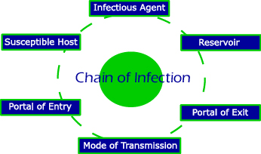

Communicable diseases
Elementary level

The best way to prevent infection, whether for COVID-19, flu, common cold, etc., is to avoid being exposed to it. That means staying away from those people who have been infected. You can also take everyday actions that help prevent the spread of illnesses.
Preventing communicable diseases:

I Whack Germs
A fun way of remembering the most important steps to staying well.
I | Immunizations are important to protect you from diseases
W | Wash your hands often with soap and water.
H | Home is where you stay when you are sick.
A | Avoid touching your eyes, nose, and mouth –especially when you are sick.
C | Cover your coughs and sneezes so you do not spread germs to others.
K | Keep your distance from sick people so you don’t get sick too.

